CSE 2320 Notes 15: Minimum Spanning Trees

(Last updated 11/8/26 11:30 AM)

CLRS 21.3, 23.1-23.2

15.A. Concepts

Given a weighted, connected, undirected graph, find a minimum (total) weight free tree connecting the vertices. (AKA bottleneck shortest path tree)

Cut Property: Suppose S and T partition V such that

1. S ∩ T = ∅
2. S ∪ T = V
3. |S| > 0 and |T| > 0

then there is some MST that includes a minimum weight edge {s, t} with s ∈ S and t ∈ T.

Proof:

Suppose there is a partition with a minimum weight edge {s, t}.

A spanning tree without {s, t} must still have a path between s and t.

Since s ∈ S and t ∈ T, there must be at least one edge {x, y} on this path with x ∈ S and y ∈ T.

By removing {x, y} and including {s, t}, a spanning tree whose total weight is no larger is obtained. •••

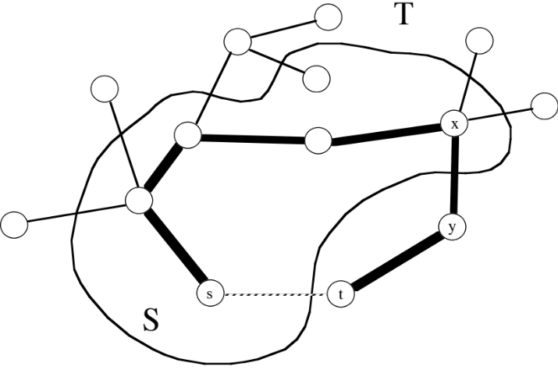

Cycle Property: Suppose a given spanning tree does not include the edge {u, v}. If the weight of {u, v} is no larger than the weight of an edge {x, y} on the unique spanning tree path between u and v, then replacing {x, y} with {u, v} yields a spanning tree whose weight does not exceed that of the original spanning tree.
Proof: Including {u, v} in the set of chosen edges introduces a cycle, but removing {x, y} will remove the cycle to yield a modified tree whose weight is no larger.

The proof suggests a slow approach - iteratively find and remove a maximum weight edge from some remaining cycle:

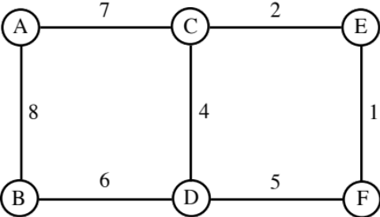

15.B. Prim’s Algorithm – Three versions

Prim’s algorithm applies the cut property by having S include those vertices connected by a subtree of the eventual MST and T contains vertices that have not yet been included. A minimum weight edge from S to T will be used to move one vertex from T to S

1. “Memoryless” – Only saves partial MST and current partition.
( http://ranger.uta.edu/~weems/NOTES2320/primMemoryless.c )

Place any vertex x ∈ V in S.
T = V – {x}
while T ≠ ∅
Find the minimum weight edge {s, t} over all t ∈ T and all s ∈ S. (Scan adj. list for each t)
Include {s, t} in MST.
T = T – {t}
S = S ∪ {t}

Since no substantial data structures are used, this takes 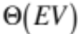 time.

Which edge does Prim’s algorithm select next?

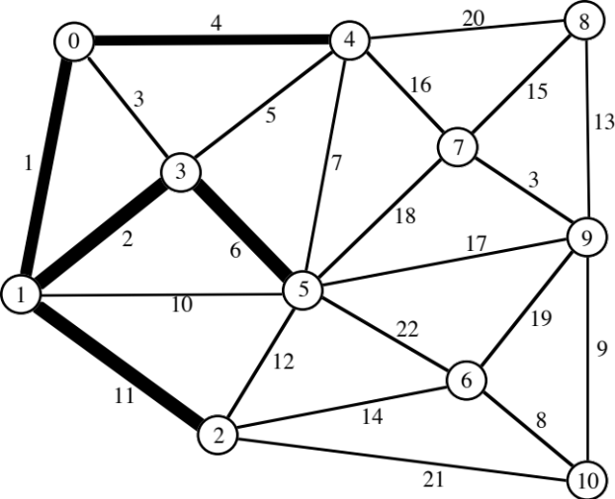
2. Maintains T-table that provides the closest vertex in S for each vertex in T.
( http://ranger.uta.edu/~weems/NOTES2320/primTable.c traverses adjacency lists)

Eliminates scanning all T adjacency lists in every phase, but still scans the adjacency list of the last vertex moved from T to S.

Place any vertex x ∈ V in S.
T = V – {x}
for each t ∈ T
Initialize T-table entry with weight of {t, x} (or ∞ if non-existent) and x as best-S-neighbor
while T ≠ ∅
Scan T-table entries for the minimum weight edge {t, best-S-neighbor[t]}
over all t ∈ T and all s ∈ S.
Include edge {t, best-S-neighbor[t]} in MST.
T = T – {t}
S = S ∪ {t}
for each vertex x in adjacency list of t
if x ∈ T and weight of {x, t} < T-weight[x]
T-weight[x] = weight of {x, t}
best-S-neighbor[x] = t

What are the T-table contents before and after the next MST vertex is selected?

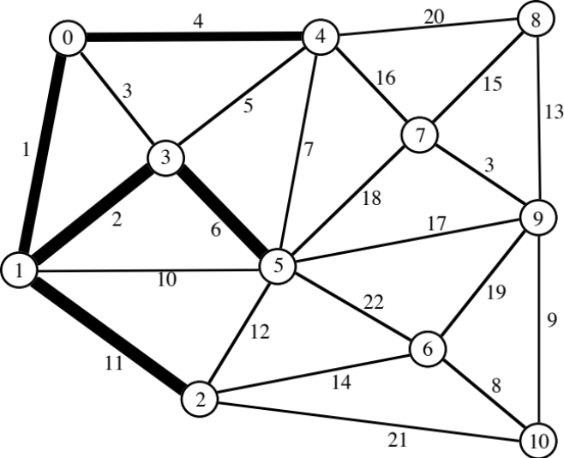

6 14 (2)

7 16 (4)

8 20 (4)

9 17 (5)

10 21 (2)

Analysis:

Initializing the T-table takes Θ(V).
Scans of T-table entries contribute Θ(V²).
Traversals of adjacency lists contribute Θ(E).
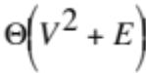 overall worst-case.
3. Replace T-table by a min-heap.
( http://ranger.uta.edu/~weems/NOTES2320/primHeap.cpp )

The time for updating for best-S-neighbor increases, but the time for selection of the next vertex to move from T to S improves.

Place any vertex x ∈ V in S.
T = V – {x}
for each t ∈ T
Load T-heap entry with weight (as the priority) of {t, x} (or ∞ if non-existent) and x as
best-S-neighbor
minHeapInit(T-heap) // a fixDown at each parent node in heap
while T ≠ ∅
Use heapExtractMin /* fixDown */ to obtain T-heap entry with the minimum weight edge
over all t ∈ T and all s ∈ S.
Include edge {t, best-S-neighbor[t]} in MST.
T = T – {t}
S = S ∪ {t}
for each vertex x in adjacency list of t
if x ∈ T and weight of {x, t} < T-weight[x]
T-weight[x] = weight of {x, t}
best-S-neighbor[x] = t
minHeapChange(T-heap) // fixUp

Analysis:

Initializing the T-heap takes Θ(V).
Total cost for heapExtractMins is Θ(V log V).
Traversals of adjacency lists and minHeapChanges contribute Θ(E log V).
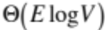overall worst-case, since E > V.

Which version is the fastest?

Theory Sparse 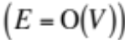 Dense 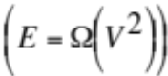

1. 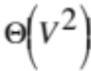 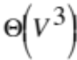
2.
3. 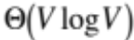 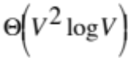
15.C. Union-Find Trees to Represent Disjoint Subsets

Abstraction:

Set of n elements: 0 . . n - 1

Initially all elements are in n different subsets

find(i) - Returns integer (“leader”) indicating which subset includes i

i and j are in the same subset ⇔ find(i)==find(j)

union(i,j) - Takes the set union of the subsets with leaders i and j.

Results of previous finds are invalid after a union.

Implementation 1: ( http://ranger.uta.edu/~weems/NOTES2320/uf1.c )

Initialization:

for (i=0; i<n; i++)
id[i]=i;

find(i):

return id[i];

unionFunc(i,j):

for (k=0; k<n; k++)
if (id[k]==i)
id[k]=j;

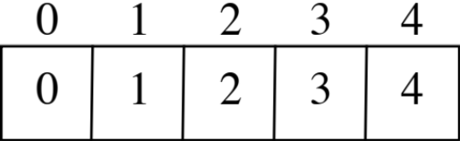

Implementation 2: ( http://ranger.uta.edu/~weems/NOTES2320/uf2.c )

find(i):

while (id[i]!=i)
i=id[i];
return i;

unionFunc(i,j):

id[i]=j;

Implementation 3: ( http://ranger.uta.edu/~weems/NOTES2320/uf3.c )

Initialization:

for (i=0; i<n; i++)
{
id[i]=i;
sz[i]=1;
}
find(x):

for (i=x;
id[i]!=i;
i=id[i])
;
root=i;
// path compression - make all nodes on path
// point directly at the root
for (i=x;
id[i]!=i;
j=id[i],id[i]=root,i=j)
;
return root;

unionFunc(i,j):

if (sz[i]<sz[j])
{
id[i]=j;
sz[j]+=sz[i];
}
else
{
id[j]=i;
sz[i]+=sz[j];
}

Best-case (shallow tree) and worst-case (deep tree) for a sequence of unions?

15.D. Kruskal’s Algorithm – A Simple Method for MSTs Based on Union-Find Trees
( http://ranger.uta.edu/~weems/NOTES2320/kruskal.c )

Sort edges in ascending weight order.

Place each vertex in its own set.

Process each edge {x, y} in sorted order:

a=Find(x)
b=Find(y)
if a ≠ b
Union(a,b)
Include {x, y} in MST

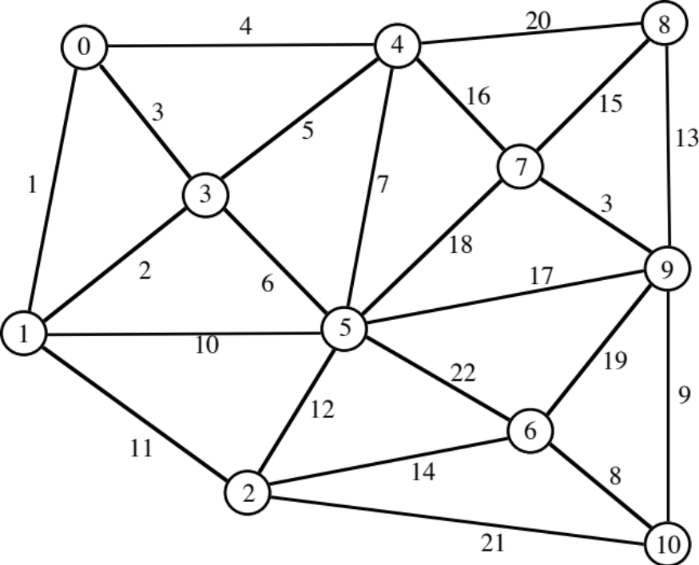

1 {0, 1}
2 {1, 3}
3 {0, 3}
3 {7, 9}
4 {0, 4}
5 {3, 4}
6 {3, 5}
7 {4, 5}
8 {6, 10}
9 {9, 10}
10 {1, 5}
11 {1, 2}
12 {2, 5}
13 {8, 9}
14 {2, 6}
----------------
15 {7, 8}
16 {4, 7}
17 {5, 9}
18 {5, 7}
19 {6, 9}
20 {4, 8}
21 {2, 10}
22 {5, 6}

Time to sort, , dominates computation

